**Practical No : 05**

**Aim:** Study and Implementation of storage as a Service.

Step1: Login to Gmail Account and go to Google Drive

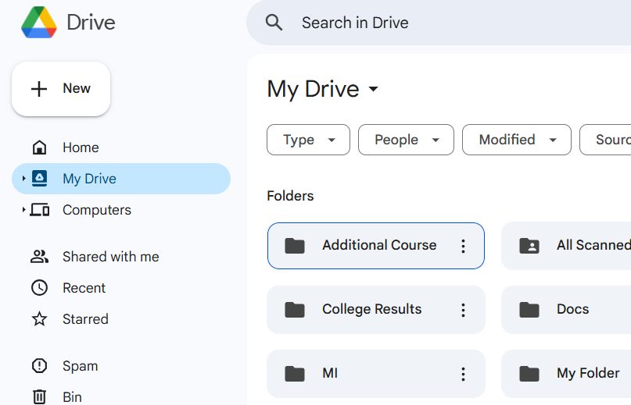

Step2: Right click on my Drive and select Google Docs

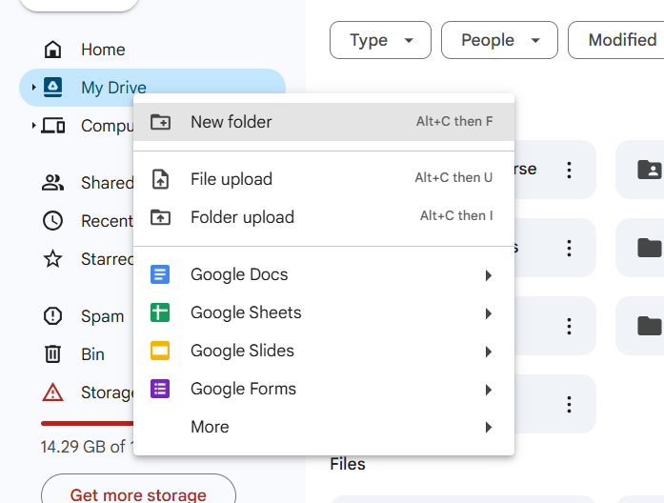

Step3: Write any content and save the document.

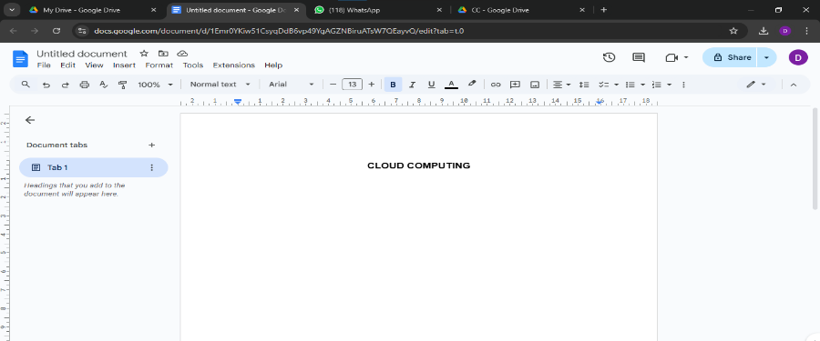

Step4: select my drive click on create slide and write any content and save it.

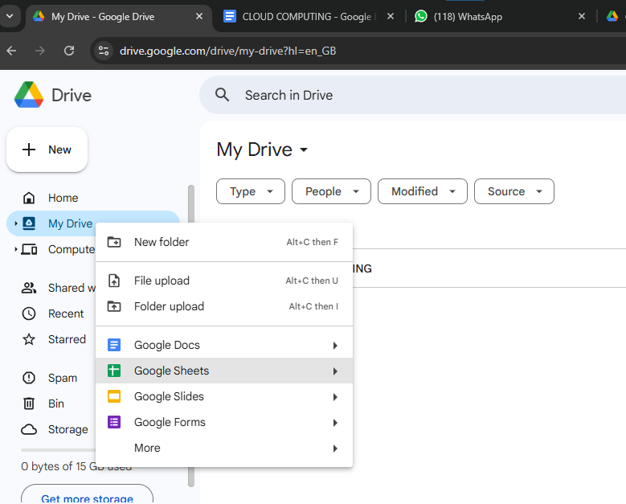 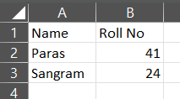

Step5: select my drive click on create slide. Write any content and save the slide.

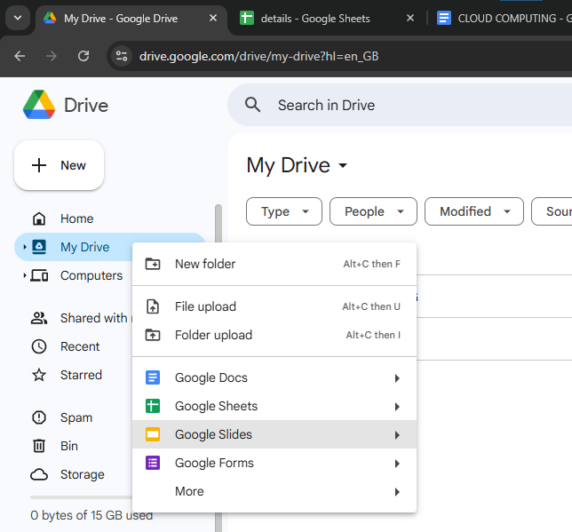 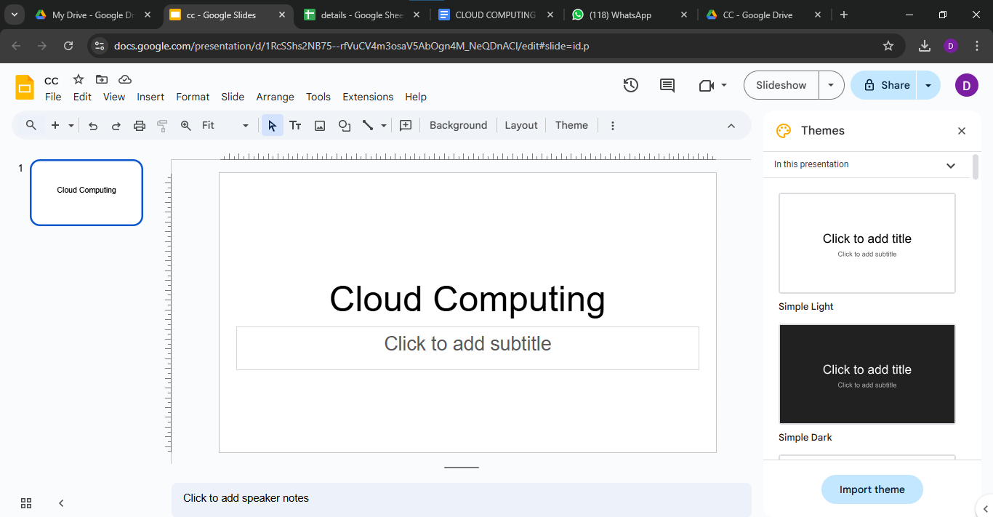

Step6: you can upload a file or folder by using upload file and upload folder tab.

